Final code submit Task
Team : The Stuffed Six

DECO3801/7381 Team Assessment AI Declaration Cover Sheet
Team Name | The Stuffed Six | Assessment Item | Statement of Work Task

Student ID | Name
48625946 | Shutong Wang
48651075 | Shaobo Ma
49119675 | Xiaoyang Zhang
49128583 | Fang Ling
49101885 | Yumeng Han
49186127 | Jiawei Zhang

The use of the following is permitted on this course only with full disclosure of how it was used and with proper attribution, you must make clear what is your teams and/or your own work:
- Open-source code and libraries (excluding previous DECO projects).
- Open data sets.
- Royalty free, free to use icons, images.
- Use of generative AI code generation tools such as Copilot and others.
- Use of generative AI tools such as ChatGPT to assist with essay writing (but only with a complete list of the prompts used).
- Use of AI grammar checkers.
Please confirm each statement by ticking the boxes before signing the bottom of this sheet. Where required provide further information in the space provided or attached on blank pages. Please note that if a team member does not agree and doesn’t sign off on the final submission of the assessment item, they must attach a statement explaining their reasons.
We declare that:
- All team members confirm and acknowledge they have signed off on the submission of this work. Each team member agrees that:  - The work submitted accurate represents the work of the team.  - Changes to the final submission have not been made without approval from the entire team. | ü
- This work, except where otherwise indicated and fully attributed, is our own original work. | ü
- This work has not been submitted for any degree or examination at any other university and/or for any other course at UQ (except where explicitly permitted). | ü
- Third party material – code/data/tutorials/work
- This work does not contain any other persons’ work, open-source work, and/or generative artificial intelligence code, data, images, graphs, tables, or any other information. | ☐
- This work does contain work inspired by, drawn from, copied from, derived from (or similar) other persons’ work, open-source work, and/or generative artificial intelligence (Gen-AI) code, data, images, graphs, tables, or any other information. Such instances have been indicated below AND are appropriately disclosed and attributed in place where the work occurs (in-text citations, reference list, code comments/braces, etc). For Gen-AI, such as ChatGPT, acknowledge below and include the full set of prompts and responses within the appendix.  - Third party material - writing |  | ü
- This work does not contain other persons’ and/or Gen-AI writing. | ☐
- This work does contain other persons’ writing and their words have been re-written, but the general information has been attributed and referenced to them as an in-text citation and in the reference list. |  | ☐
- This work does contain other persons’ writing and their exact words have been used within quotation marks and has been attributed and referenced to them as an in-text citation and in the reference list. |  | ☐
- This work does contain Gen-AI work (with or without modification). Gen-AI has been used to aid writing. The sections it has been used in are listed below. Include the full set of prompts and responses within the appendix. |  | ☐
- This work has not been refined, revised, translated, transformed, or similar by any AI tool. | ☐
- This work has been refined, revised, translated, transformed, or similar by any AI tool. The tools and description of use are listed below. |  | ü
- We have checked this work to ensure that there are no instances of academic misconduct, including plagiarism herein. | ü

The University defines Academic Misconduct as involving ‘a range of unethical behaviours that are designed to give a student an unfair and unearned advantage over their peers’. The University takes Academic Misconduct very seriously and any suspected cases will be investigated through the University’s standard policy.
We hereby declare that we understand the meaning of academic misconduct and recognise that the submission of work for assessment that includes instances of academic misconduct is an offence that may result in disciplinary action being taken against us.
Name | Signature | Date
Shutong Wang | 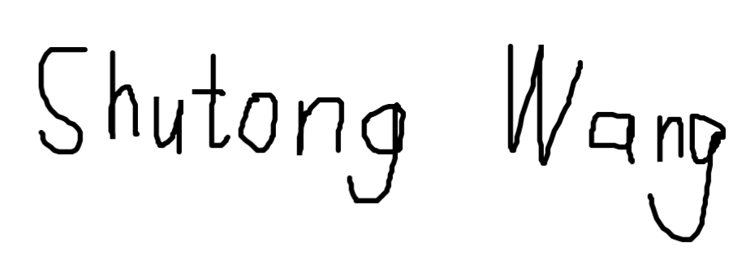 | May 20, 2026
Shaobo Ma | 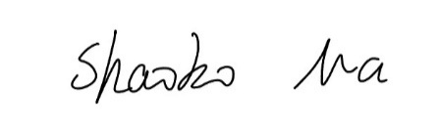 | May 20, 2026
Xiaoyang Zhang | 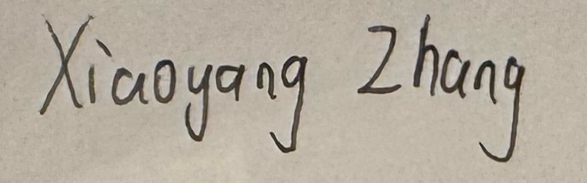 | May 20, 2026
Ling Fang | 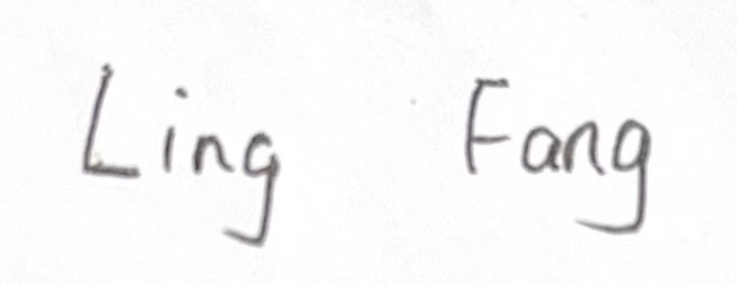 | May 20, 2026
Yumeng Han | 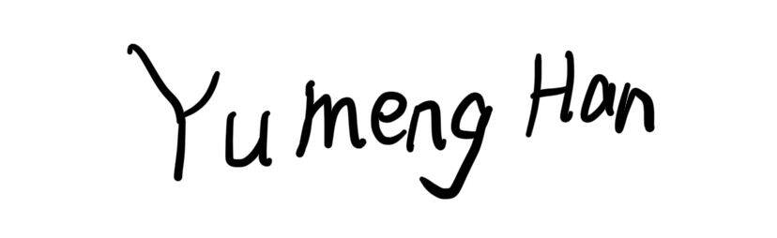 | May 20,2026
Jiawei Zhang | 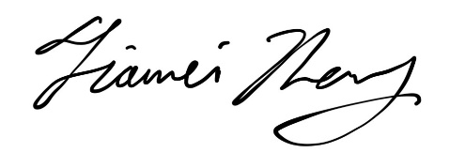 | May 20,2026

Ai usage:
The team’s AI use declaration and prompt log are included in the submitted codebase folder as AI.md and AI_log.md. These files summarise how AI tools were used during the project and record the prompts used to support wording refinement, translation, technical explanation, debugging assistance, and report drafting All AI-assisted outputs were reviewed, edited, and verified by team members before being included in the final submission.

